Name: _______________________________________ Date: _________________ Block: ____
Japan and the Koreas Section 3 Vocabulary and Notes (pg. 788-795)
Term | Definition and Sentence | Drawing/Image
Limited government | D: a government whose powers are limited by law.  S: South Korea has a limited government as long as the country is not facing a serious problem.
Unlimited government | D: a government that, by law, may take any action it wants.  S: North Korea has an unlimited government.
Dictator | D: someone who has total control over the government.  S: Kim Jong-il was a dictator. | 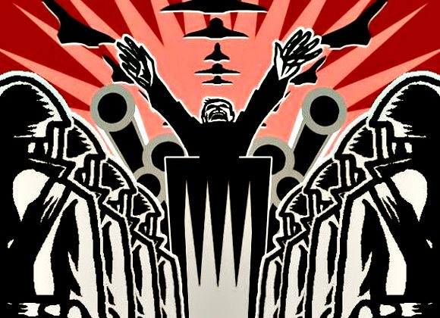
Recession | D: a time when an economy becomes weaker and does not grow.  S: In the 1990s Japan suffered a recession.
Shinto | D: a traditional Japanese religion in which Kami or spirits are worshipped.  S: Many people in Japan practice both Shinto and Buddhism. | 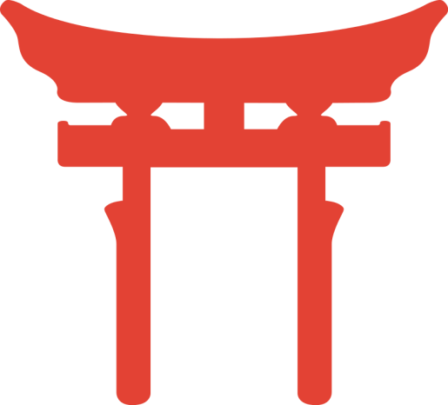

Is Kim Jong-il a dictator? Explain.
Yes. He is a leader who has complete control over the government of his nation.

Why has North Korea’s nuclear program created conflict in the region?
North Korea has continued to develop and test nuclear weapons despite earlier promises not to.
Other countries feel threatened.

Why is Japan’s aging population causing economic problems?
The increasing aging population requires more financial support. Also, there are fewer young
people entering the workforce.

Why does the North Korean government limit access to outside information?
Outside ideas might cause North Koreas to rebel.

